# Software Projects M3 - Concept Design Model

## Group 20

## Garden Assistant Application

## Use Cases

1. **Professional Stakeholder Use Case** (i.e. Botanist, researcher, enthusiasts etc...):

Add plants to existing garden plan

Draw and plant out a plan for a garden

User

Database of plants used in garden plans

Database of plants

Database of stored garden plans

Use calendar for updates on garden

Manage multiple saved gardens

check database for information on plants

1. **Normal User Stakeholder Use Case** (i.e. Hobbyists, Aspiring enthusiasts, User seeking small-scale agricultural ventures for health/sale, Aesthetically pleasing garden etc...): Based on incomplete market research most users falling into this category are the middle-aged/elderly.

**Sequence List**

* Open the app
* Enter their login details
* A menu of all of the features are displayed
  + Plan and draw the garden
  + View personalised calendar
    - Review event
    - Add event
    - Receive alert
  + Viewing database of plants

Update calendar with plant selection

Add plants to existing garden plan

**Scenario 1 – logging in to see the menu of features:**

User

View database of plants

Update calendar with new event

Fetch user’s personalised data

Add calendar event

View personalised calendar

Plan and draw garden

1. The user opens the app.
2. They are greeted by the login screen, where the must enter their username and password.
3. The system will then verify whether the login details are correct.
4. If the details are correct, the user may access their account.
5. If the details are incorrect, an error message will be displayed to the user, prompting them to enter their login details again. Hence, access denied.
6. A menu is displayed to the user where they can then access any of the following features: drawing feature, calendar feature, viewing the database of plants.

**Scenario 2 – using the drawing features:**

1. The menu is displayed on the screen and the user presses the ‘DRAWING’ feature to create/view/edit their garden plan.
2. If this is the first time they are using the drawing feature, a blank canvas will be displayed.
3. They can then plan out their garden by selecting the plants they would like in their garden.
4. As they select a plant, important information will be displayed about the best position for optimal sunlight etc.
5. If they confirm this plant, the important information will be transferred to their personalised calendar to remind them of upcoming events to maintain the plant.
6. However, if the user has already created a plan for their garden, when accessing this feature, their plan will be displayed and can be edited.

**Scenario 3 – using the calendar feature:**

1. The menu is displayed on the screen and the user presses the ‘CALENDAR’ feature to view their personalised calendar.
2. The system fetches the user’s data (from their personal account including information about the plants they selected from the drawing feature).
3. The calendar is displayed to the user highlighting key dates. For example: water the plants.
4. The user can enter their own key dates by pressing another button.
5. A short form is displayed where the user must complete the required fields.
6. If all fields are completed, the system accepts this request and updates the user’s calendar.
7. If the required fields are not completed, an error message is displayed prompting the user to complete the short form again. Hence, the event is not created.
8. The system will also send notifications to the user’s device of upcoming events on their calendar as well as weather updates for that day.

**Scenario 4 – using the plant database feature:**

1. The menu is displayed on the screen and the user presses the ‘PLANT DATABASE’ feature to view their personalised calendar.
2. The system fetches the information from the plant database and displays them to the user.
3. The user can scroll through all of the different plants and view information about them.
4. **Back-End Support Stakeholder Use Case** (i.e. Software Support Employees):

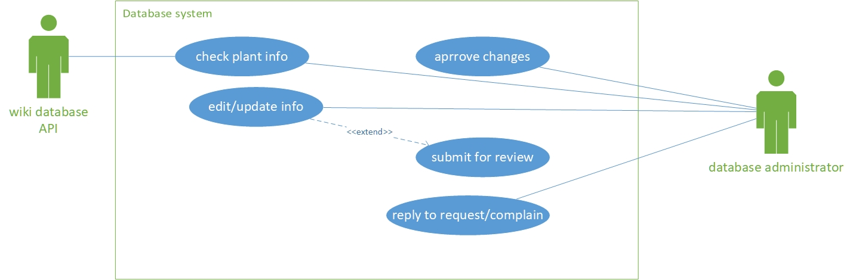

**Sequence List**

1. Uploads data/verifies database
2. Have access to all features
3. They want to navigate the application in order to assist users with any issues they may come across

* The user (administrator) opens the ‘Garden Assistant’ application.
* Admin inputs their log-in details (administrator log-in) that opens an administrator account with special privileges.
* Admin opens the ‘Plant Information’ tab/database.
  + Admin inputs information that relates to a specific plant or vegetable.
  + Admin then saves this information, which is stored on the database from that point onwards.

**(BRANCHING PATH)**

* + Admin verifies pre-existing information on specific plants to verify that it’s up-to-date and correct.
    - If it’s correct, admin leaves the information as it is.

**(BRANCHING PATH)**

* + - If it’s incorrect, admin syndicates information from external website (outsources).
      * + Admin accesses the “User complaints/service tab.
        + Admin searches for requests/complaints

**(BRANCHING PATH)**

* No support required then admins job is done.
* Admin identifies issues
* Resolves issues depending on their format

**(BRANCHING PATH)**

Email/forum

## End user Sequence Diagram

Due to professional/normal users having a cross-over in which they both utilize the application in the same manner, albeit with different motives, a plausible sequence diagram for the two is below:

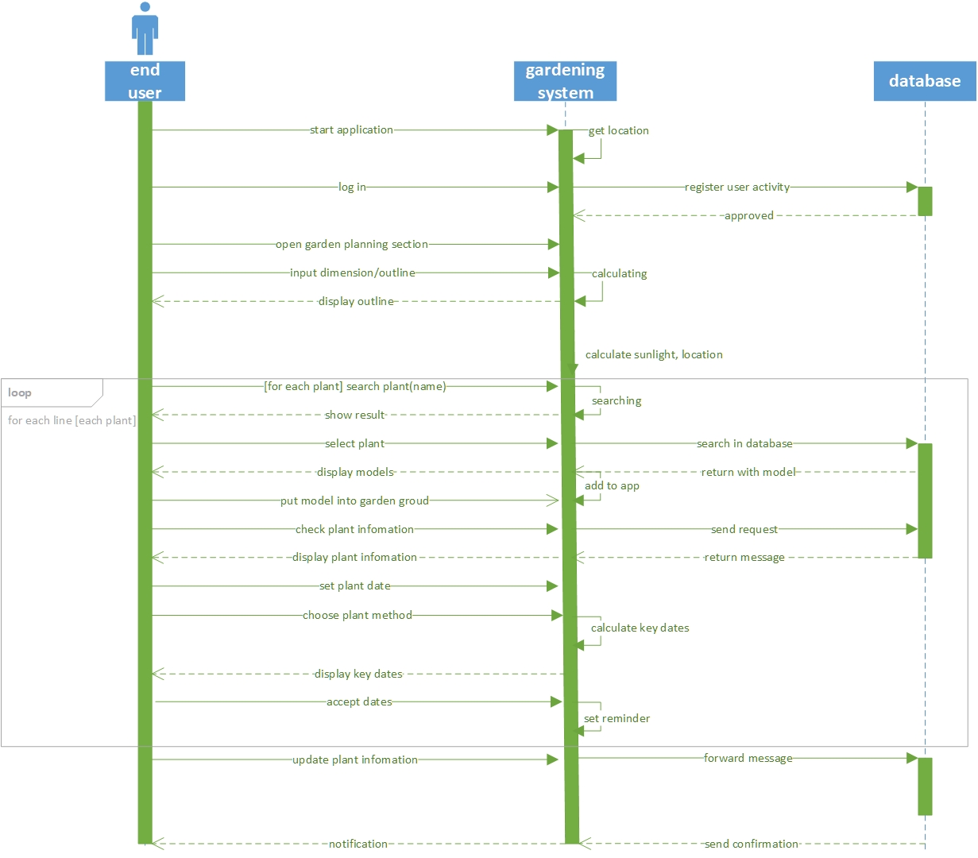

## Back-End Support Sequence Diagram:

## Activity Diagram

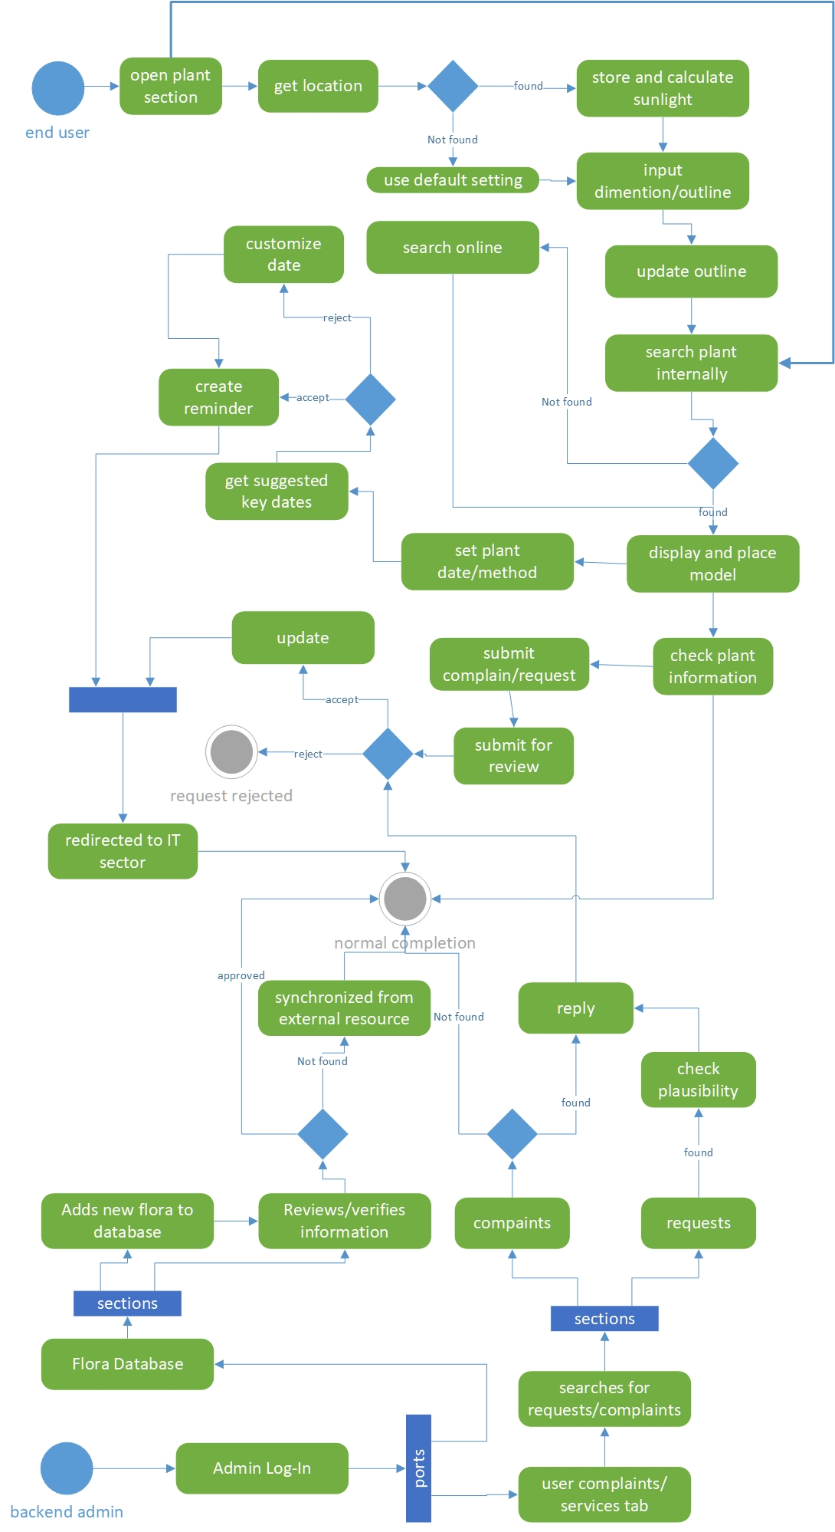

Update: We managed to solve to problem

~~Due to a misunderstanding that use cases were shaped around application features as opposed to stakeholder uses, we are currently unable to provide the activity diagram because of time constraints, however we will hopefully have generated one come the M4 submission.~~

## Open Questions about this concept

1. Have all stakeholder use cases been covered?
2. Are the sequence diagram accurate illustrations of the processes that different users will undergo when pursuing their needs with the application?
3. Are satisfying these needs realistic or are we overreaching with our aspirations for this application?
4. Is our incomplete market research a feasible foundation for these diagrams?